SQL 7

Consider the following employees and departments tables from the sample database:

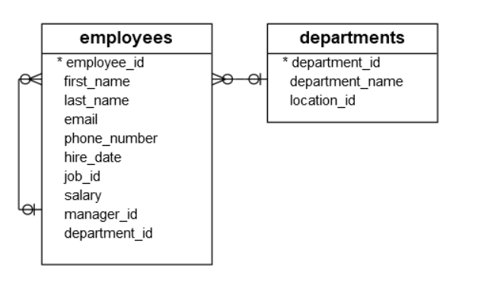

1. find all departments located at the location whose id is 1700

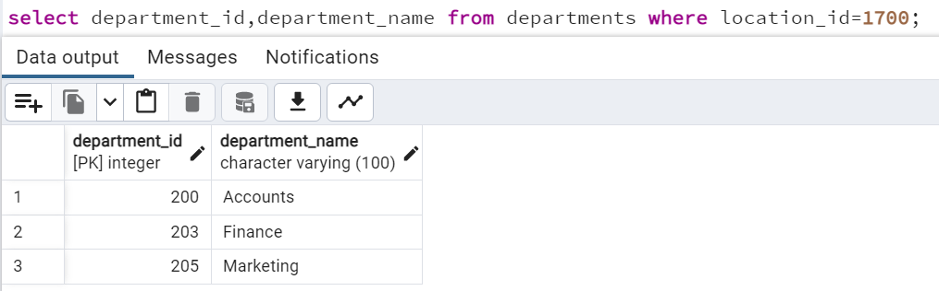

1. find all employees that belong to the location 1700 by using the department id list of the previous query

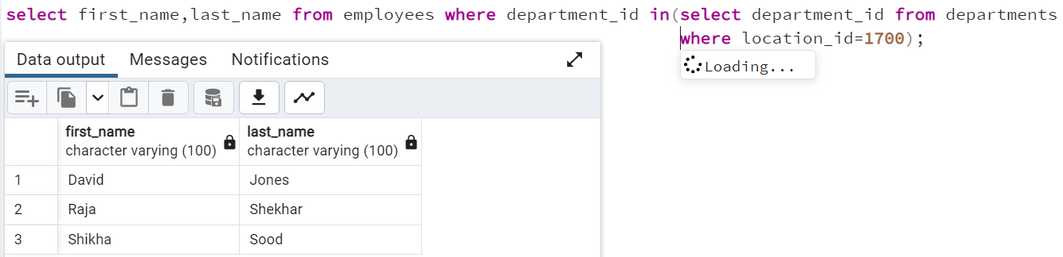

1. find all employees who do not locate at the location 1700

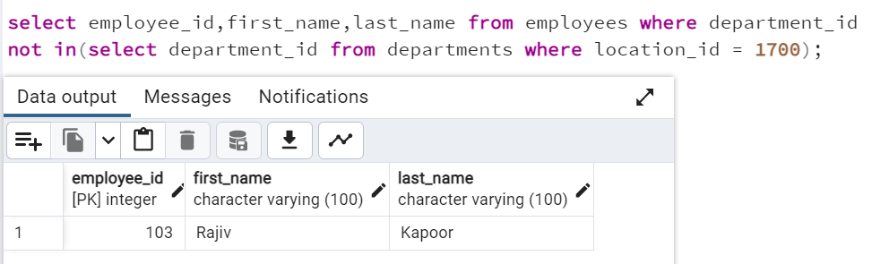

1. finds the employees who have the highest salary

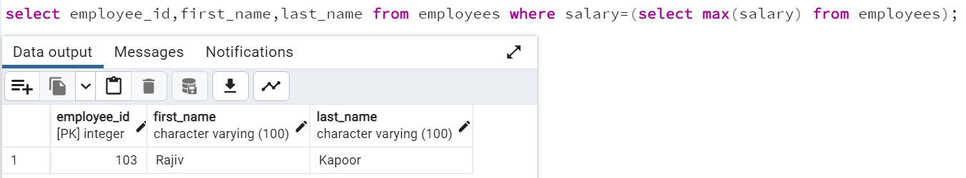

1. finds all employees who salaries are greater than the average salary of all employees

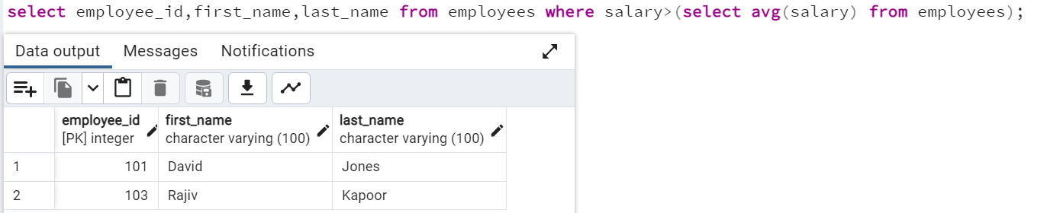

1. finds all departments which have at least one employee with the salary is greater than 10,000

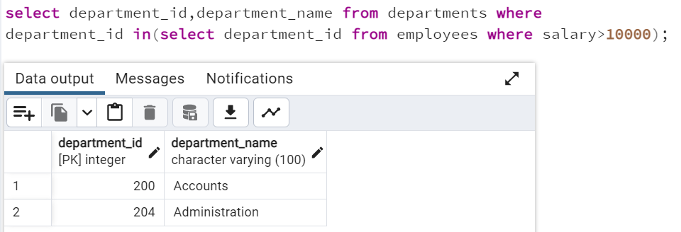

1. finds all employees whose salaries are greater than the lowest salary of every department

